Executive Summary
Career Progression and Promotion Gap Analysis for Retention Optimization at Palo Alto Networks

The Problem
Employees rarely leave an organisation only because of a single bad experience. More often, they leave after a long, quiet build-up of unmet expectations: not being promoted for years, staying in the same role too long, receiving little training, or losing a stable manager relationship. Standard attrition tools tell an organisation who might leave, but not why — leaving HR teams to react with generic retention offers rather than addressing the specific career issue behind each person's disengagement.

What We Did
We analysed HR records for 1,470 employees at Palo Alto Networks and built four measures of career health for every employee: how overdue they are for a promotion, how long they have sat in the same role, how much training they are receiving, and how stable their manager relationship has been. Using these measures, employees were grouped into four career-path segments using two independent statistical methods that agreed with each other 72.5% of the time — giving high confidence that the groupings reflect real patterns rather than statistical noise.

What We Found
Finding | Figure
Employees at High risk of promotion-related disengagement | 445 of 1,451 (30.7%)
Employees identified as priority retention opportunities (not yet disengaged, but stagnating) | 366 employees
Employees who would benefit from a training/development plan | 334 employees
Attrition rate for employees with unstable manager relationships vs. stable ones | 17.7% vs. 14.5%
Largest at-risk group | "Promotion-Stalled" segment — 279 employees

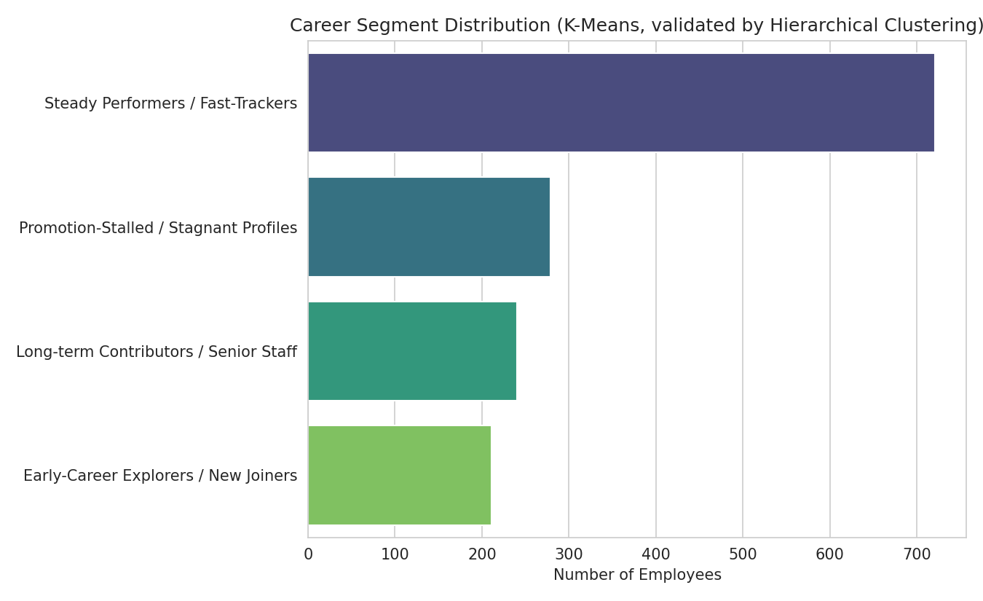
Employees grouped into four career-path segments

What We Recommend
- Prioritise the 366 identified employees for career conversations this quarter, before they reach a stage of active disengagement.
- Run a formal promotion review for the 279 employees in the "Promotion-Stalled" group.
- Provide targeted training plans to the 334 employees flagged as under-developed relative to their tenure.
- Examine manager-continuity practices in teams where employees frequently change managers, given the link to higher attrition.

The Tool We Built
Alongside this analysis, we delivered an interactive dashboard that lets HR leaders filter by department, role, career stage, and risk level; explore each career segment; simulate the impact of promoting a given percentage of high-risk employees; and export a ready-to-use list of priority employees with suggested next steps for each one. This turns a one-time analysis into a repeatable tool the organisation can revisit every quarter as new HR data comes in.

Bottom Line
This project gives Palo Alto Networks a way to see which employees are quietly stalling in their careers — before they leave — and gives concrete, individualised next steps for each one. It shifts retention strategy from reacting after someone resigns to intervening early, based on evidence rather than guesswork.

